YXDXXHD-WD
Indoor Ceiling Mount Single Sided
2500nits Digital Window Display

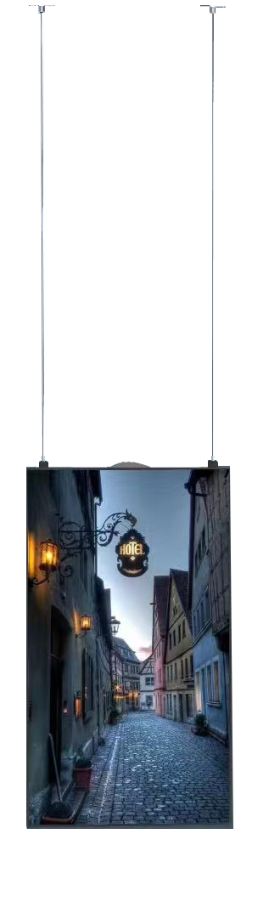

Panel Size | 43inch | 49inch | 55inch | 65inch | 75inch
Model No. | YXD43HD-WD | YXD49HD-WD | YXD55HD-WD | YXD65HD-WD | YXD75HD-WD
LCD specification
Active Area | 941.18×529.42 | 1073.78×604 | 1209.6×680.4 | 1428.5×803.5 | 1650*928mm
Contrast ratio | 1200:1 | 1200:1 | 1400:1 | 1400:1 | 1400:1
Resolution | 1920*1080/3840*2160 | 1920*1080/3840*2160 | 3840*2160 | 3840*2160 | 3840*2160
Brightness | 2500cd/m2 (3000cd/m2 high TNI panel is optional)
Direction | Vertical/horizontal optional
Color | 16.7M
Viewing angle | 178/178
LED backlight | Yes
Display mode | Landscape or portrait mode are optional
Response time | 8ms
Life | 50000(hrs)
Hardware Specification
CPU | RK3568
Memory | 2GB
Nand flash | 16GB
Storage port | USB, SD card
OS | Android 11
WiFi | Yes, inbuilt WiFi(802.11b/g/n); 4G optional
Power
Power supply | 90-132VAC/180-264VAC(Select by the transfer switch)
Operation temperature | 0℃-60℃ (no condensation)
Operation humidity | 10%-85% (no condensation)
System function
Support video | MPEG1/MPEG2/MPEG4/AVI/VOB/MOV/WMV/DIVX/RM/RMVB, support super HD 1080P/2160P video
Support picture | JPG/JPEG/PNG/BMP
Support TXT | TXT/WORD/EXCEL/PDF
Support Website | HTML/ASP/JSP/PHP
Support RSS | Internet RSS title and text, flip over/page turning
Long-distance control | monitoring the terminal display image in real time
Image rotate | support 90°,180°,270°image rotate
Software upgrade | Support upgrade software by USB disk
Structure
Install method | Ceiling Mounting/Wall Mount
Color | Black
Speaker | Built-in speaker is optional
Brightness sensor | Yes, built-in
Working Time | 7*24hours
Pictures
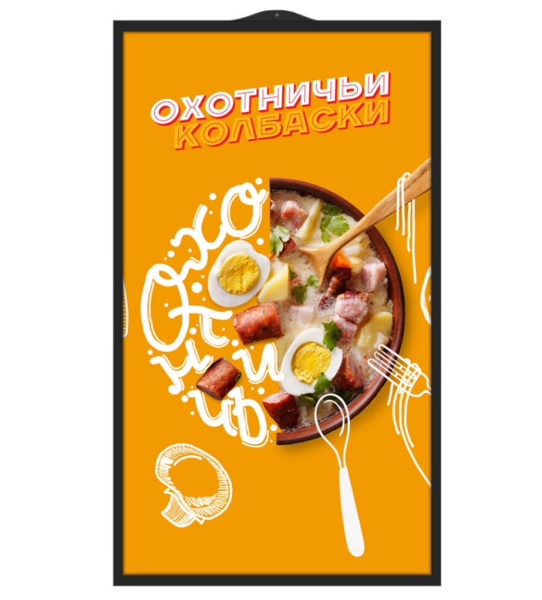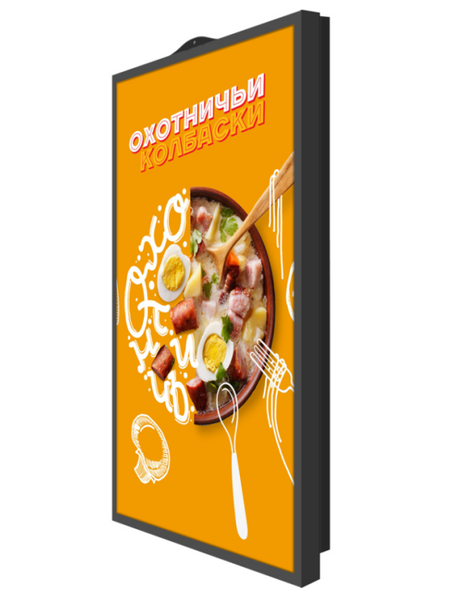

Dimension
43inch:
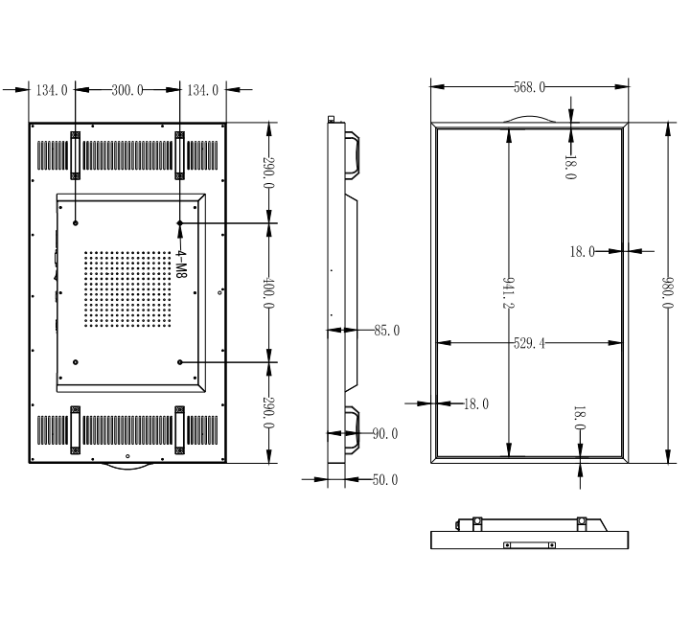
49inch:
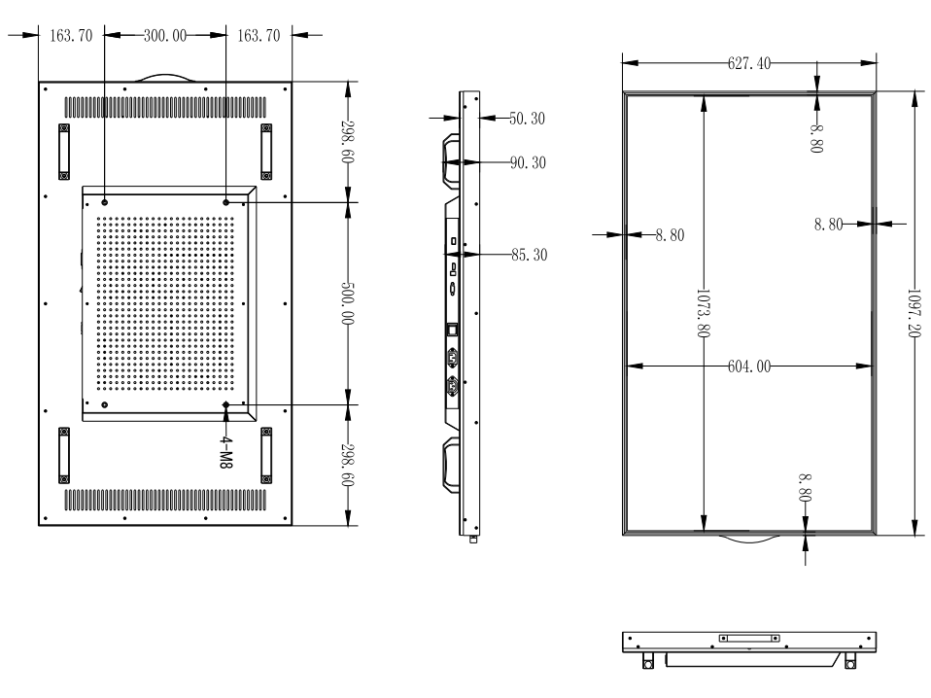

55inch:
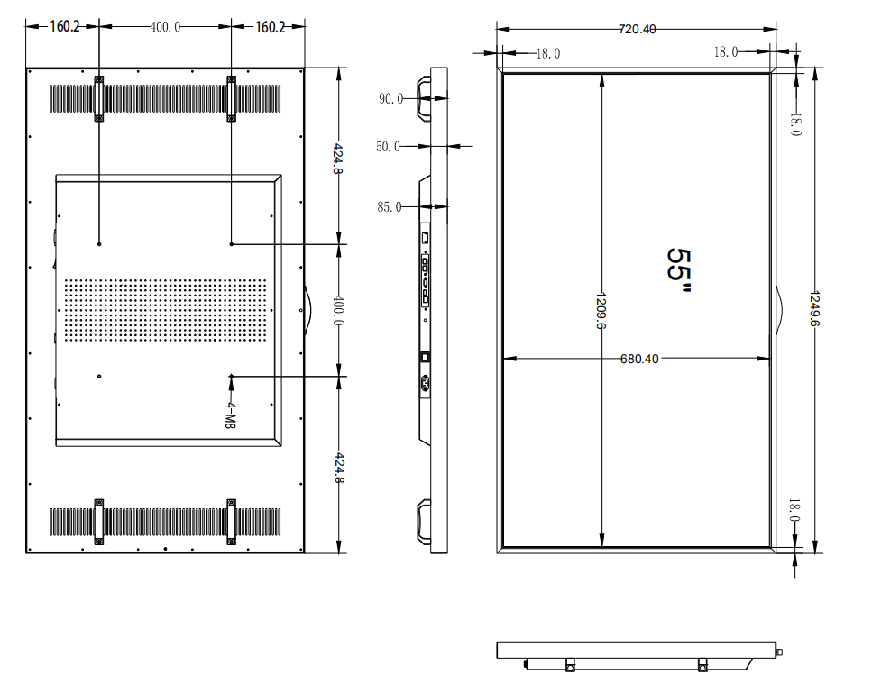

65inch:
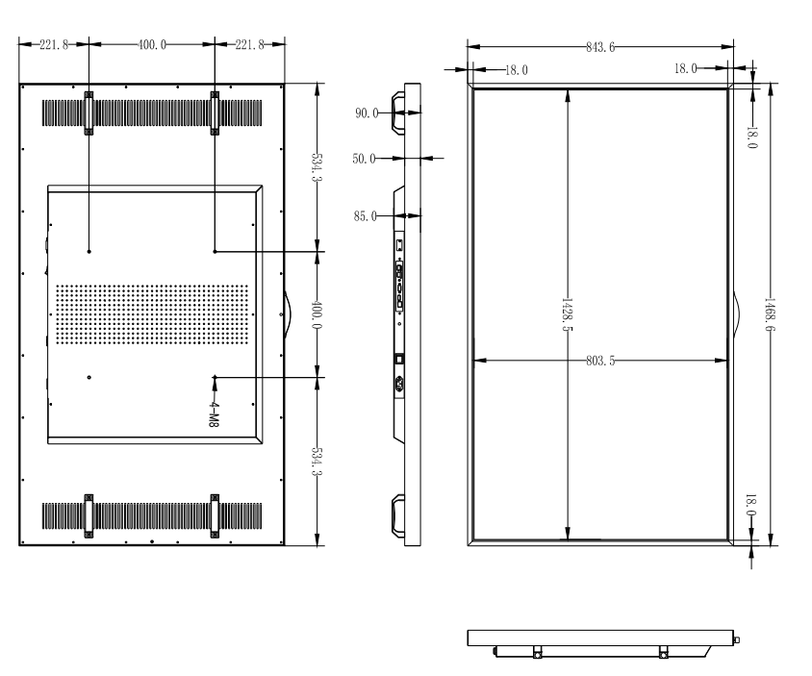
75inch
